Published 29th. January 2021 by Jørn Watvedt for UpWork project.

31 Jan Rev 2: Added details for Raspberry PI

Joystick piloting for outboard motorboats was a popular topic 10 – 15 years ago, when the major manufacturers started developing and offering these systems. However, the excitement has much died off because of complexity, limited user benefit, high price, and the inherent limitations of big money big industry proprietary systems.

However, since then, there has been a revolution in vehicle piloting driven mostly by open-source contributions to the RC and especially RC / autopiloted drones. Now time is right for revisiting boat joystick piloting and all the current smart navigation opportunities that has become available thru ArduPilot and the associated hardware. Not only that, but quality, reliability and safety of these current technologies are certainly competitive, compared to current industrial solutions (which are 10 years old …..)

Outboard motorboats with 2 motors that are controlled independently in respect to throttle, shift, steering, and trim have vast opportunities for total boat control. Much like that recent controllers with gyro/compass/GPS/PID instrumentation made drone piloting possible, these same technologies are now ready to unleash similar transformation for outboard motorboats with 2 (or more) engines.

Now time is right to start, and start small, with a common RC boat, equipped with 2 outboard motors with independent controllers. Make it work with regular dual joystick RC controller, one joystick for each motor and a sea-trial will be convincing; Perform a sideways walk by vectoring the engines such that the resultant vector pushes the boat directly sideways. And so on!

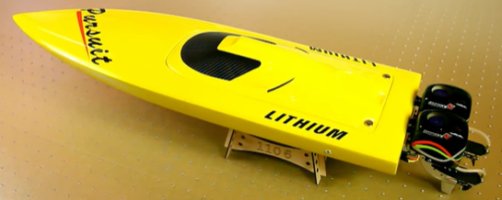

The objective of this project is to start small, start simple with current RC boat equipment and iterate and iterate and iterate. Maybe one day we feel confident to move the controller onto a full-size boat.

**Phase 1: RC boat with 2 outboard engines controlled by individual joysticks.**

|  |  |  |
| --- | --- | --- |
| Item | Description |  |
| 1 | Hull spec: Length 60 – 70 cm  Initially, a Tupperware plastic box will do, but more elegant with a boat hull that also provide (dry) space for electronics, batteries and some ballast. |  |
| 2 | Two outboard engines with steering .  Sample technical data for “TFL Brushless Outboard Motorassembly”  Length: 137mm  Wide: 36mm  Height: 106mm  Max speed: 70km/h  Suit for 70A ESC  Power – 450-KV3000 |  |
| 3 | Rudder steering servo, with connector for direct connection to the Receiver.  Installation brackets and levers etc required.  Recommend double symmetrical servo arm with stiff rod connection to the motor for sturdy steering. |  |
| 4 | Electronic Speed Controller ESC for outboard motors. Our project does not need to run these engines hard, I would say occasionally maybe full throttle for a short time. Consequently, I think the ESC of maybe same as motor is ok, although twice of the is recommended. Need to be fairly watertight.  Water cooling is required for lengthy sea trials. |  |
| 5 | Receiver  4 channels is sufficient initially  Recommend RC industry standard components.  2,4 GHz seems to be the norm  FHSS or FASST - ?? | FlySky 6 Channels RC Receiver (Compatible with FS-i6 Transmitter) |
| 6 | Battery pack  ? |  |
| 7 | Controller must have dual joysticks, one for each motor, hence minimum 4 chanals, but 6 channels may be smart for future switching?  Suggest start with simple cheap controller. |  |
|  |  |  |
|  |  |  |

**Phase 2: Add simple controller for software vectoring of motors.**

Operational mode settings:

* Dual joystick = Forward/backward and steering individually for the motors
* Single joystick = Strict synchronized operation of motors in tandem.
* Single vectored joystick = Attempt to vector such that boat move in the joystick direction.
* Maybe ideas about other operational modes?

Objective is to be able to play with different settings and understand the dynamics of having two articulated motors.

Each operational mode probably requires a table of SETTINGS that may be updated to experiment with and better understand boat behavior.

**Phase 3: Define system hardware and software.**

Now we are ready to define with ArduPilot and what hardware to use for compass, gyro and GPS.

Issues: Cost, availability, competence required, and so on.

Ardupilot has several steering options:

<https://ardupilot.org/rover/docs/rover-motor-and-servo-connections.html>

Also different versions of vectored thrust:

<https://ardupilot.org/rover/docs/rover-vectored-thrust.html#rover-vectored-thrust>

Joystick piloting allow straight sideways movement of boat, as an illustration of what is possible, by vectoring.

Sketch explaining motor vectoring for sideways movement: Motor A and Motor B have angular direction and force, which is revectored into Ax/Ay and Bx/By respectively.

The resultant force R = Ax+Bx is pushing the boat sideways IF resultant moment from all forces around “COJ” ( Center of Joystickoperation = think of CoG Center of Gravity but for water friction forces) = 0 zero. Controller must be able to run this calculations.

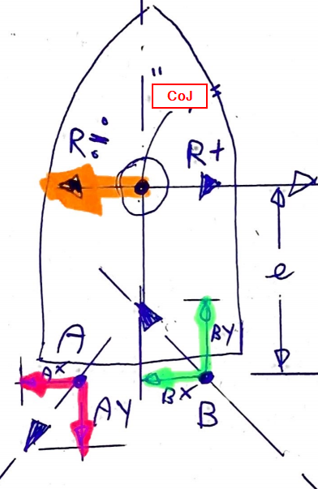

Ardupilot has several steering options:

<https://ardupilot.org/rover/docs/rover-motor-and-servo-connections.html>

Also different versions of vectored thrust:

<https://ardupilot.org/rover/docs/rover-vectored-thrust.html#rover-vectored-thrust>

**Phase 4:**

Update Boaty McBoatSurFace with new System for sea trials.

Identify issues and strategies to solve these issues.

**Phase 5:**

First full RC system

**Phase 6:**

RC System Ver 1.0

**Phase 7:**

Define Real Boat System

Real Boats us NMEA 2000 for data transfer, and there is an Open Source solution for communication:

<http://signalk.org/>

We are going to use Raspberry PI:

<https://seabits.com/nmea-2000-powered-raspberry-pi/>

**Phase 8:** Build hardware for Real Boat System.

**Phase 9:**

Develop and install software on the Real Boat System. Sea Trials

**Phase10:**

Real Boat System Ver 1.0